

RECOMMENDATION FOR UPGRADATION

Up gradation” is defined as advancement to the next higher salary grade which is made primarily on the consideration of an employee’s tenure. Generally an employee will be eligible for an up gradation if he/she has worked in the same grade for at least 6 years without any break in service. To be considered, the employee must not have a disciplinary action taken against him/her in the 2 years prior to when he/she becomes eligible for up gradation, have achieved a Rating/ Satisfactory Score in the Performance Appraisal during this period and has no objection to the up gradation.
Our records show that Mr./s. Name , ID#........... , Designation:……………………….and having met the above criteria is eligible for up gradation this year. However, before the up gradation can be implemented, we need an NOC from your end as the supervisor. Therefore, please tick the appropriate box below and explain in the case that you have an objection to the up gradation.
I have no objection for the up gradation of Ms/ Mr. _________________ I object to the up gradation of Ms/ Mr.
Explain elaborately your views for objection, if any

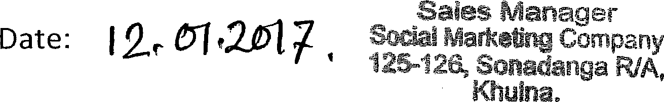
Name and Signature of the Supervisor

Name and Signature of the Divisional Head


Please send the completed form to Manger- HR, SMC EL Tower, Banani, Dhaka

